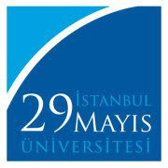
Istanbul 29 Mayis University
School of Foreign Languages
English Language Preparation Program
2020-2021 INTERMEDIATE TRACK EXAM ANSWER KEY
LISTENING  PART I  1. C  2. C  3. nutrition  4. D  5. B  6. C  PART II  1. C  2. symbols  3. A  4. D  5. B  6. C | READING I  A.  - artist \ accountant  - stereotypes  - limited knowledge  - advertisements\ jokes  - see the world  - realize\ become aware\believe  B.  - Steven( Jackson) and Marta (Jackson)  - A man in a pin-striped suit and briefcase(NOT Steven Jackson)  - Stereotypes  - Children  - Adults | READING II  A.  - b  - c  - a  - e  - g  - d  - h  B.  - adventure seekers\holiday makers\adventurers  - intensive training course  - scientist and researchers  - sandstorms and scorpions  - ( high) altitude
USE OF ENGLISH  1. A  2. D  3. B  4. D  5. C  6. B  7. A | VOCABULARY  1. D  2. B  3. C  4. A  5. D  6. B  7. C  8. D

